**William Bates**

William Bates was resident at 55 Vale Road, Bushey when he enlisted as Private 29883 with the 7th Battalion of the Bedfordshire Regiment in June 1916. In November he was drafted to the Western Front, where he took part in some important engagements, including those of the Somme, Ypres and Cambrai. He was wounded and taken prisoner and died of his injuries on 14 May 1918. He is remembered with honour at Hautmont Communal Cemetery, grave reference I. A. 6., and is commemorated on the Bushey Memorial and at St James’ Parish Church and at St Paul’s in Bushey.

[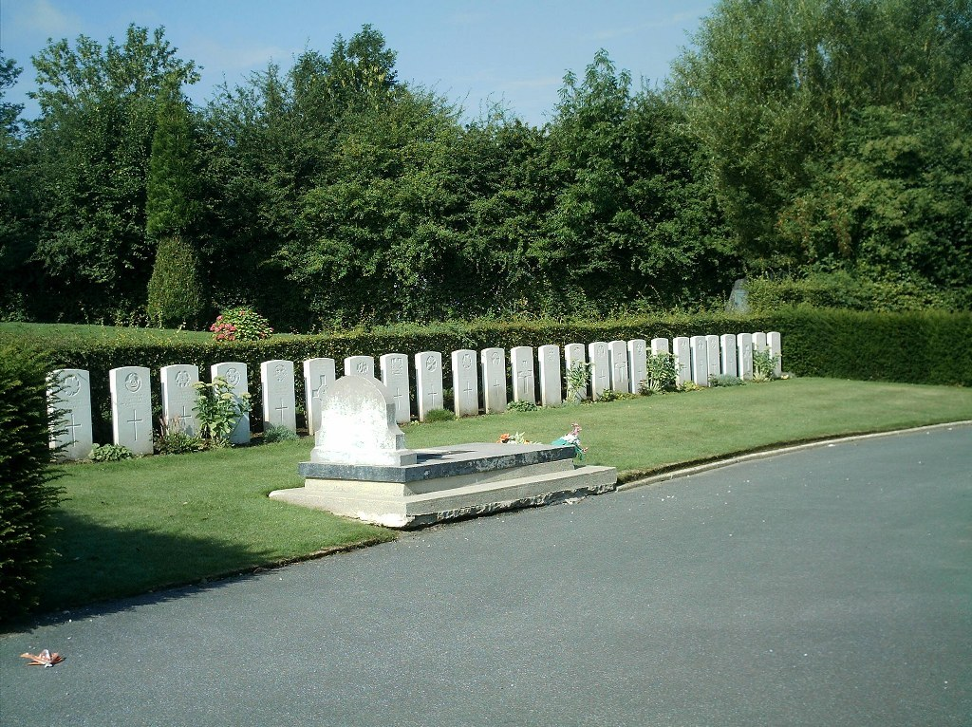](http://www.cwgc.org/dbImage.ashx?id=10438)