**Robert Cobbett**

Robert Cobbett was born in Nunhead, Surrey, in about 1885. In 1911 he was 26 and employed as a barman in a public house at 37 Hertford Road, Lower Edmonton.

He enlisted in the Royal Army Service Corps and served as Corporal M/205265 in East Africa. He died on 23 December 1917 and was buried in Dar Es Salaam War Cemetery. His wife, Ada Alice Cobbett, moved to 57, Vale Road, Bushey after the war.

[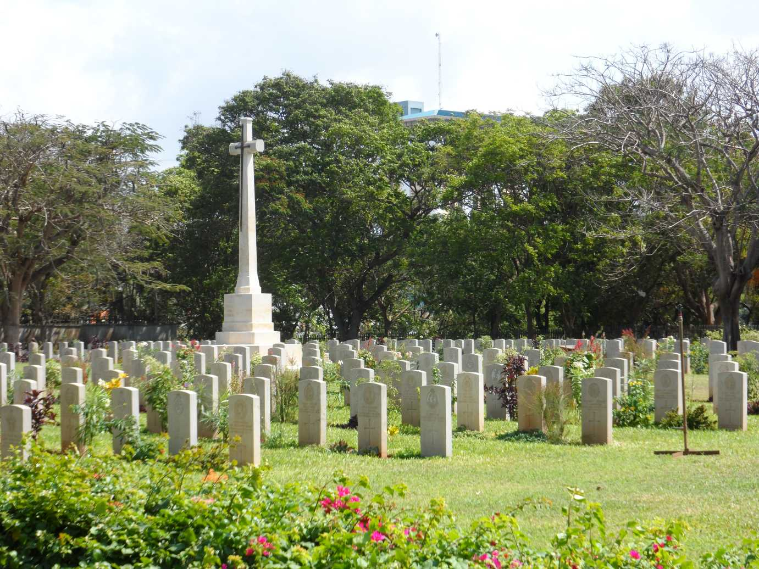](http://www.cwgc.org/dbImage.ashx?id=14978)