**George Edward Loud**

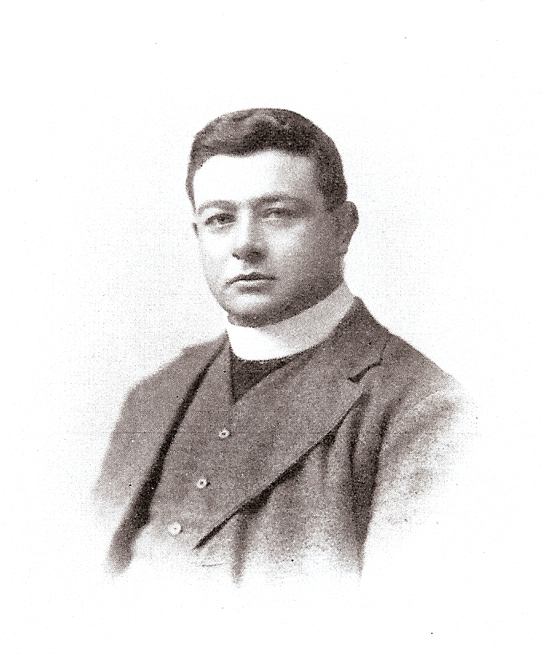

George Edward Loud, born on 5 April 188l, was the son of Mark and Rebecca Walker Loud, of Chelsey, near Eccleshall in Staffordshire. He was educated at Hanley Higher Grade School, Denstone College, and Jesus College, Oxford, where he held a Mathematical Exhibition. He joined the staff of The Royal Masonic School in 1905, was ordained deacon in 1906 and priest the following year. He became a Housemaster in 1914. During the eleven years spent in the service of the School he was held in more than ordinary affection by his colleagues and the boys, for in chapel, classroom, house and on the playing-fields he exhibited all those qualities which Englishmen most admire - frankness, fearlessness, impartiality, generosity and geniality. The call of his country proved irresistible to him, and in December, 1916, he decided to join the London Regiment as a Private, refusing to accept a chaplaincy in the forces, because he was determined not to avoid hardship or danger undergone by his fellows.

He trained at Canterbury and elsewhere and went to France with a battalion draft in July, 1917. Shortly afterwards he was transferred to the King's Royal Rifles. In the trenches he became the confidant and counsellor of his platoon, and every night he conducted impressive, though informal, services in some dug-out. Early in March, 1918, he was taken prisoner and sent to the Prisoners' Camp at Munster in Westphalia. He died of pneumonia following a chill on 27 June, 1918, at Bottrop Camp Reserve Hospital, and is buried in the municipal cemetery at Bottrop, where his fellow-prisoners have erected a stone in memory of him.

Source: Memorials of Masonians who fell in the Great War (1922)

He served as Private 648314 in the London Regiment, 20th Battalion. He now lies buried in Cologne Southern Cemetery grave reference XV. A. 35

He is commemorated on the Bushey Memorial.

[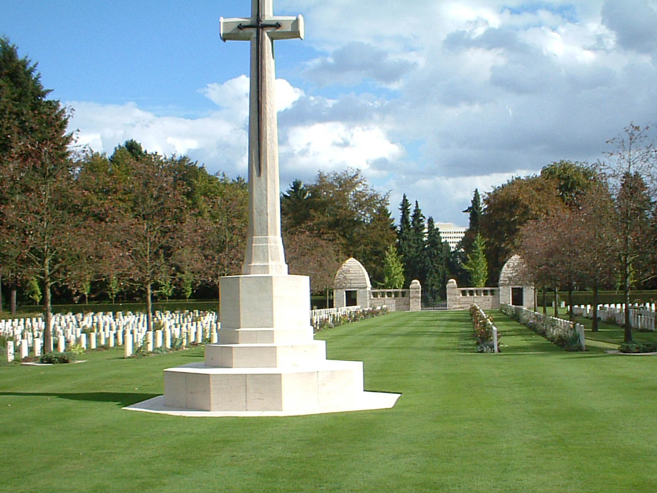](http://www.cwgc.org/dbImage.ashx?id=12261)