**John Leeson Moffet**

John Leeson Moffet was born in Watford in 17 May 1888, the elder son of Thomas and Elizabeth Moffet. His father was an Assistant and Land Agent to the London & North Western Railway Company, Chairman of the Watford Public Library and a member of the Watford Urban District Council. John was educated at Watford Grammar School from 1896 until 1903 and Manchester University, where he graduated with a degree in engineering. After leaving university, he became an engineering assistant for the Lancashire and Yorkshire Railway Company. The Moffet family originally lived in Watford but by 1911 they had made their home at ‘Ingleside’, 53 Kingsfield Road, Oxhey.



John served in the Manchester University Officers’ Training Corps for four years and when war broke out he applied for a commission. On 5 September 1914 he was gazetted Second Lieutenant to the Royal Scots Fusiliers. He went to France on 26 January 1915 and was killed in action a few weeks later on 10 March at Neuve Chapelle. An officer serving with him wrote to his parents: ‘I was in the same company as your son and only ten yards away when he was killed. We had been advancing in extended order when we suddenly struck some heavy rifle fire. Your son was in front of me and had just given the order to his platoon to lie down, when he was stuck by a bullet through the left lung and died at once, without speaking. He died a noble death, leading his men into action and it was through turning round himself to warn his men to take cover that he was himself hit’.

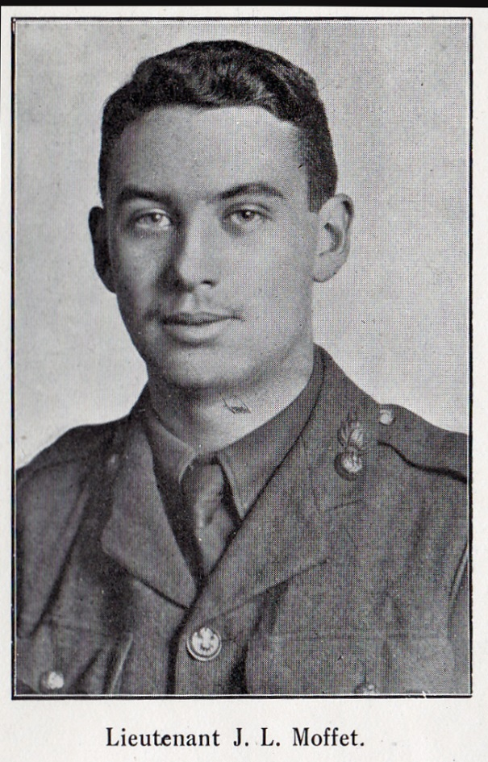

John Leeson Moffet was buried at Guards Cemetery, Windy Corner, Cuinchy in northern France. He is commemorated on the St Matthew’s Parish Church memorial and at Bushey and Oxhey Methodist Church.

[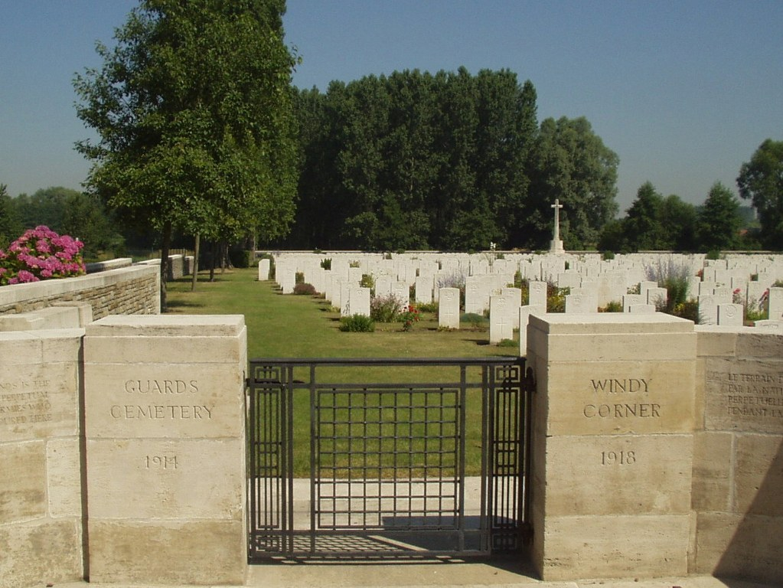](http://www.cwgc.org/dbImage.ashx?id=10407)